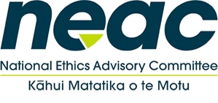
National Ethics Advisory Committee
ZOOM
19 May 2020

Item |  | Time
 | Welcome  - Sign off minutes and annual report update | 10am-10:15am
2. | - Ministry update on Equity Framework for Resource Allocation progress  - NEAC discussion of Framework  - Consultation content and list of target consultees sign-off | 10:10am – 11:30am
3. | Break | 11:30am-11:45am
4. | - Aim: NEAC sign off Framework  - Discussion – work item NEAC National Statement | 12:00pm - 1:10pm
5. | Correspondence received  - B4School Check – Data Ethics Discussion with stakeholders | 1:10pm – 1:40pm
6. | Meeting summary and close | 1:40pm – 2pm

