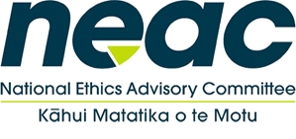
National Ethics Advisory Committee
8 December 2020
9:00am-1:30pm via zoom

Item |  | Time
 | Welcome | 9:00am
2. | Declarations of Interests  a. Review declarations of interests  b. Declare any conflicts of interest/role regarding today’s agenda and determine how to manage any conflict
3. | Minutes of NEAC’s 3 November 2020 meeting: for approval
4. | APNEC report back from meeting on 25 November 2020
5. | Briefing to the incoming Minister of Health – approve the BIM
6. | Project work: Getting through together  - Agree to the ethical principles that will set the subsequent guidance  - Agree to the structure of the document  - Agree a work plan including working groups with NEAC members leading sections with Secretariat support  - Agree to proposal to hire contractor to support, as well as identify what advice NEAC would like from the principal advisor for clinical ethics  - Agree to a clear time frame for a first draft of GTG to be completed and released for public consultation.
7. | HDC report and modifications of consent discussion: Discussion about a  way forward with:  - Martin Than  - Ron Paterson  - Mark Marshal  - John Pickering.
8. | Meeting close | 1.30pm

