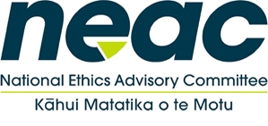
National Ethics Advisory Committee
Ministry of Health – via ZOOM
29 April 2020

Item |  | Time
 | Welcome | 9:30am - 9:40am
2. | Ministry update on Equity Framework for Resource Allocation progress | 9:40am - 10:45am
3. | Right 7(4) update from HDC and discussion on moving forward:  - Cordelia Thomas and Rose Wall – Office of the Health and Disability Commissioner attending  - Monique Jonas and Lana Lon – Health Research Council attending | 10:45am - 11:45am
4. | Break | 11:45am-12:00pm
5. | Correspondence received  - Noting item: Clinical Ethics Submission Email  - Noting item: Letters from Nurses Organisations  - B4School Check – Data Ethics Advice Request | 12:00pm - 1:10pm
6. | Ministry of Health Update and Meeting the Minister  - Gene editing working group update and seek NEAC views  - Consent modifications meeting update – no feedback required at this stage  - Chair meets Associate Minister of Health on 28 May 2020 to approve NEAC’s upcoming work programme  - NEAC discuss any other matters to raise with Minister | 1:10pm – 1:40pm

