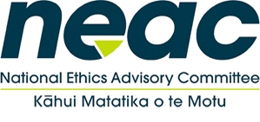
National Ethics Advisory Committee
Ministry of Health - ZOOM
24 June 2020

Item |  | Time | Supporting documents
 | Welcome  - Introduction of members and welcome to new members  - Confirmation of minutes of NEAC 19 May 2020 meeting - NEAC action required: sign off | 10:00am – 10:20am | Minutes
2. | Ministry updates  - Framework for Allocation – update on consultation  - Ministry of Health COVID Ethics Project – Rob Update  - Diligent boards update  - NEAC Annual Reports (2017-2019) - NEAC action required: sign off  - Letter to Minister – HDC report on research with adults who cannot provide informed consent  - NEAC Work Programme update – time frames and milestones  - Review of Getting Through Together  - Annual Survey of users of NEAC Ethical Standards for Research and QI | 10:20am – 11:00am | Annual Reports  HDC Letter
3. | Revision of Getting Through Together – Ethical Values for a Pandemic  - Project overview – please review the attached project briefing and guiding questions  NEAC action required: discuss and agree work plan and process for updating the document  - Next steps | 10:50am - 11:45am | Project brief – NEAC Getting Through Together Review
4. | Meeting review and close  - Confirmation of action points from meeting  - Next meeting date(s) | 11:45am-12:00pm

